The Feeding of the Five Thousand
John 6:1-15

Introduction:

I. The Setting – 6:1-4

A. The Time –

“After ﻿﻿these things…”

We learn from the other Gospels that “These things” included:

- Herod Antipas had killed John the Baptist (Mark 6:14-29; cf. John 3:24),
2. The disciples had preached throughout Galilee (Mark 6:7-13, 30-31),
3. Multitudes of people were curious about Jesus, and Herod Antipas was seeking Jesus (Luke 9:7-9).

So, the time between the events in John 5 and 6 was probably six months.

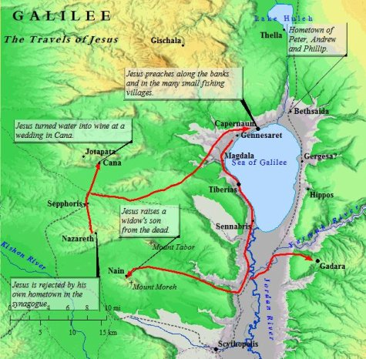
B. The Territory – 6:1b

“Jesus went over the Sea of Galilee, which is the Sea of ﻿﻿Tiberias.”

(Different from the Mediterranean Sea) Jesus went to the N.E. shore of the Sea of Galilee. He went there for rest, especially since hearing of the death of John the Baptist. (But, that rest didn’t last very long)

C. The Throng – 6:2

“Then a great multitude followed Him, because they saw His signs which He performed on those who were ﻿﻿diseased. “

The throng followed Him on foot along the shore of the sea to this remote place (Matt 14:15) This was a result of His recent ministry in Galilee.

D. The Rest – 6:3

“And Jesus went up on the mountain, and there He sat (was sitting) there with His disciples.”

The mountains were probably the Golan Heights. “was sitting” is important, showing that He didn’t just sit down, He was there awhile.

E. The Feast – 6:4
﻿
“Now the Passover, a feast of the Jews, was near.”
This is one of the three Passovers during Jesus’ ministry years. He attended the first and third.

Question: Why did John mention it here, so far away from Jerusalem?

Maybe it was for chronological purposes. Jesus is about 2/3 of the way through His ministry. Or John uses that to explain why the Jews tried to get Jesus to go to Jerusalem to be crowned King; at the Passover.

II. The Situation – 6:5-9

A. Jesus Anticipated the Problem

1. The Number of People – 6:5a

“Then Jesus lifted up His eyes, and seeing a great multitude coming toward Him,”

2. The Need for Food -- They are not hungry yet. But they will be.

B. Jesus Asked Question – 6:5b

“He said to ﻿﻿Philip, “Where shall we buy bread, that these may eat?”

He directed the question to Philip, but later on we will see that other disciples were listening or Philip told them. Philip was from this area, Bethsaida

C. The Purpose of the Question – 6:6

“But this He said to test him, for He Himself knew what He would do.”

Jesus purpose was to test Philip (and the others). God tests people to refine their faith, never to tempt them to do evil.

Question: What was Jesus looking for? Maybe the disciples had learned something. Maybe they would remember: The water into wine or other miracles which Jesus performed in Galilee. Then they would say, “You can do it.” But instead Philip thought on the temporal level.

D. The Answer to the Question – 6:7

“Philip answered Him, ﻿﻿“Two hundred denarii worth of bread is not sufficient for them, that every one of them may have a little.”
One denarius was a wage for a day. 365 days – 52 Sabbath days = 333 days so, 200 denarii equals 2/3 of a year’s salary. Think of 2/3 of your annual salary for one meal. That is a formidable task. Even if that much food were available! That is for everyone “to have a little”

E. Andrew’s Contribution – 6:8-9

“One of His disciples, ﻿﻿Andrew, Simon Peter’s brother, said to Him, “There is a lad here who has five barley loaves and two small fish, ﻿﻿but what are they among so many?”

Andrew had a few doubts, but he brought the boy’s lunch to Jesus anyway.

There was another miracle here: A young lad had not eaten his lunch until “late in the day”. And let’s not forget the boy’s mother, the lunch-packer. You don’t have to be there to get the credit for service for Jesus. The barley bread was the food of poor people. [Wheat cost three times as much as Barley. Rev. 6.6]

III. The Solution – 6:10-13

A. The Seating – 6:10

“Then Jesus said, “Make the people sit down.” Now there was much grass in the place. So the men sat down, in number about five thousand.”

(The other Gospels tell us that the “in number” meant by 50’s and 100’s) This method made it easy to serve and easy to count.

B. The Eating – 6:11

“And Jesus took the loaves, and when He had given thanks He distributed them ﻿﻿to the disciples, and the disciples to those sitting down; and likewise of the fish, as much as they wanted.

C. The Gleaning – 6:12-13﻿

1. They Gathered the Fragments – 6:12

So when they were filled, He said to His disciples, “Gather up the fragments that remain, so that nothing is lost.”

2. They Counted the Fragments – 6:13
﻿
Therefore they gathered them up, and filled twelve baskets with the fragments of the five barley loaves which were left over by those who had eaten.

IV. The Surprise – 6:14-15

A. The People Properly Interpreted the Sign – 6:14

“Then those men, when they had seen the sign that Jesus did, said, “This is truly ﻿﻿the Prophet who is to come into the world.”

B. They Improperly Applied the Sign – 6:15
﻿
﻿“Therefore when Jesus perceived that they were about to come and take Him by force to make Him ﻿﻿king, He departed again to the mountain by Himself alone.”

